Learning, Teaching & Training Activity
Political and Intercultural Literacy

Varde, Denmark
March 27-31, 2017

REPORT

Host:
10i Campus, Varde, Denmark

Participants:

C.E. Rivas Luna, Valencia, Spain

CFPIMM, Lordelo, Portugal

Colegiul Tehnic Mihai Bacescu, Falticeni, Romania

Tartu Tamme Gümnaasium, Tartu, Estonia

Tevfik Seno Arda Anadolu Lisesi, İzmit, Turkey

Project Year 2016/ 2017

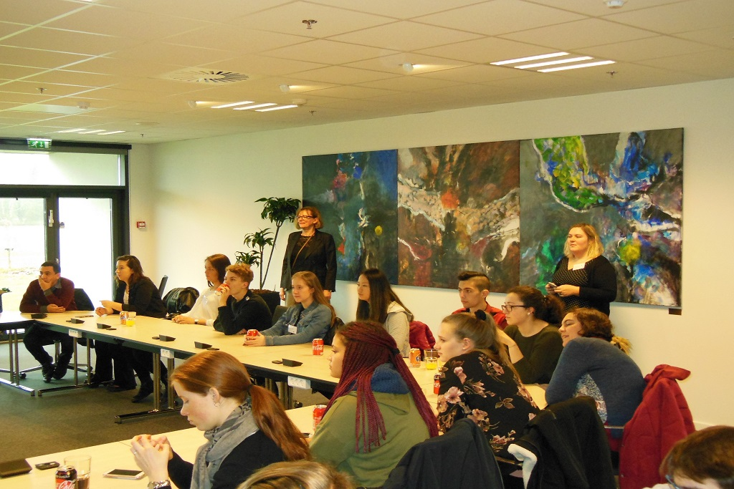

Dear partners

We got together with 31 students and 12 teachers to focus on political and intercultural literacy during five busy days in early spring Denmark. There were activities on critical thinking and problem solving, public speaking and active listening, cooperative learning and innovation. As a result, all participants broadened their knowledge of democracy, citizenship, human rights, political standards, immigration and refugees, as well as cultural differences. Everyone improved their foreign language and intercultural communication skills. Also, the students learned to discuss and debate, work in a team, assert themselves and make compromises.

This time, each partner school team had prepared a lovely presentation called “My country in a bag”, and one or more speeches to express their opinions on topics they felt strongly about. They had prepared themselves well at home on topics such as democracy, citizenship and human rights, so everyone was ready to follow the guest speakers and participate in lively group discussions. Once again, a wonderful atmosphere was created thanks to the synergy between our cordial host team and the participants.

We enjoyed a warm welcome at Varde town hall and highly educative field trips to Ribe and Esbjerg. Having just listened to a presentation on democracy, then discussed various democracy-related dilemmas in form of group work, it was great to talk to the representative of the local government to learn how democracy works in everyday practice. Also, visiting the Ribe Viking Museum and the Esbjerg’s Fisheries and Maritime Museum greatly educated us. Listening to Mrs. Andersen about the relations between the church and the government in Denmark, and to Laura about young people in politics, made everyone generate new ideas. Finally, we learned quite a bit by calling on a local folk school and a local theatre club.

A thousand thanks to the Danish team, the students and their parents for making us feel welcome!

Yours
Triin

30 May 2017 in Tartu

Introduction

There are many reasons for enhancing intercultural competence, be it adapting to global and domestic workforce diversity, improving multicultural health-care communication, deepening mutual understanding between different nations, or simply raising one’s intercultural sensitivity. Historically, crossing cultural differences became topical after World War II, when Americans had to implement the Marshall Plan. In the post-war period intercultural training was offered to sojourners and international students. During the succeeding decades the target groups varied from Peace Corps volunteers to international corporations, from degree students to global nomads and from marginalised and disadvantaged groups to host nationals. At present, intercultural competence training addresses all those who need to interact interculturally at every level.

Intercultural communication in the EU is traditionally related to the building of European identity, European citizenship and social cohesion. However, it is not as easy as it seems. First off, most EU citizens tend to identify themselves with their home societies. Also, human beings need a particular cultural horizon to make sense of the world. Ever growing ethnical, cultural and linguistic diversity in Europe, however, has changed the composition of the population of European nation states, and achieving a novel sense of cultural unity has been considered crucial for the sake of cross-cultural peace. (European Commission 2007)

To achieve this, the Council of Europe has launched several initiatives to promote the linguistic diversity of European nations, foster their ‘plurilingual’ competence and intercultural awareness. The EU, in turn, has funded initiatives where culture and politics are mixed, for example, Intercultural Dialogue. Numerous educational programmes have been launched to create better conditions for intercultural interaction between educators and academics to support the designing of relevant study materials. (Europublic 2007)

In order to discuss such important issues as human rights, democracy, respect and tolerance, gender equality, cultural liberalism, religious change, citizens’ support for European integration, political literacy in young Europeans needs to be improved in parallel with intercultural literacy. One needs to understand that everything is based on culture, which can be analysed on either individual, group or institutional level. Also, one will have to learn to come to terms with value differences.

Can we cover all the above mentioned topics just during one learning, teaching and training activity? Certainly not. But we did cover some of them rather well. All together, we had four learning sessions, during which we dug deeper into the issues Europe is currently facing (e.g. immigration, integration, democracy, economy and political standards), thought of various ways of being good citizens, discussed the pros and cons of democracy, and tried on the shoes of political leaders of the ideal country of C.L.I.C.K.

Our students also learned how to make a good public speech. They had chosen their topics and prepared their scripts at home, so in Varde they were ready to present their ideas with great enthusiasm. Even the shyest of them opened up and enjoyed convincing others on things that mattered. There is no doubt that our students improved their public speaking skills through highly creative presentations on their home countries.

This report summarizes the activities carried out, gives some background information on political and intercultural literacy (to be used in the e-book). It also summarises and briefly evaluates the learning activities carried out. The report then looks at the second mid-term evaluation of the project, and suggests next steps concerning our last transnational project meeting in Valencia. The report draws from various relevant online resources, the information provided by the host school 10iCampus and the participants’ personal observations.

The paper is divided into four parts: Concepts and Background Information, Learning Activities, Evaluation and Next Steps. There are four annexes: The Programme of LTTA 3, Hopes and Fears Summary, The List of Participants and The Checklist of Sessions. The Pre- and Post-test Results are missing.

Enjoy.

Part 1: Concepts and background infromation

1.1. Political literacy

According to Heater (quoted in Maitles 1997), “the nature and logic of democracy needs a politically educated population, capable at the very least of differentiating between the policies of the main political parties, with an understanding of how democratic institutions work and their importance, and with knowledge of how to vote.” However, many people have little idea of basic political issues. Political ignorance is thought to be the consequence of political apathy along with a limited understanding of political rights and responsibilities. So political education should be implemented in schools in order to instruct students how to intervene in the political landscape, i.e. how to participate as citizens.

Henry Maitles then highlights some counterarguments. First, it has been claimed that mass participation does no good for true democracy. Second, political education is not suitable for young people because they are not mature enough to resist the manipulation of the ‘trendy lefties’, allegedly responsible for teaching ‘biased’ political education.

Is political literacy about content or skills? Maitles argues that the latter seems to be more relevant in order to spot bias and exaggeration, analyse critically different pieces of evidence, weigh up sources and come to conclusions, as well as develop skills for investigating issues. Still, the content and the skills should not be separated as responsible citizens need to have positive caring values such as tolerance and empathy to live peacefully in a multi-cultural society.

Maitles suggests that political education should involve history and social issues, introduction to legal issues, critical reasoning, ethics and moral instruction, community based learning, understanding the global and multicultural dimension. Students should learn at school how to debate, articulate and discuss political issues though active learning, role play, group discussion and dialogue.

What is the role of teachers? As Maitles puts it, they should know that teaching democracy will not be a panacea where governments 'let down' the aspirations of their populations. Still, there is clearly value in citizens being politically literate, so teachers should develop political literacy in their students while making sure they keep some kind of realistic perspective. (Maitles 1997)

1.2. Intercultural literacy

The American Intercultural Communication expert Milton Bennett (2011) claims that culture can be studied at four different levels: institutional (Political Science), individual (Cross-Cultural Psychology), institutional and individual combined (Cultural Studies), and group (Intercultural Communication). Dr. Bennett further explains that in the 1920s and 1930s culture was predominantly viewed as ‘civilization’ and mankind was accordingly divided into the civilized, the barbarian and the savage. Later, cultural relativists claimed that no culture should be compared against one another as they all exist in their own context and right. Still later, the ‘Iceberg metaphor’ was introduced, according to which individuals would have no more problems in communication with strangers once they had mastered “the hidden unconscious” part of culture. Finally, the idea of culture as experience and creations was generated by the anthropologists who claimed that there was nothing unconscious in it.

Intercultural communication experts usually ask three questions: a) how do diverse groups communicate? b) how do people identify themselves? c) how can people become more culturally competent? (Bennett 2011) The Bennett scale, also known as The Developmental model of Intercultural Sensitivity (DMSI), is then considered one of the most effective instruments to measure the readiness of the learner to acquire new knowledge and skills in intercultural communication. It is based on cognitive psychology and constructivism, and it conveys the idea that one’s experience of cultural difference [italics original] becomes more sophisticated as one’s competence in intercultural relations increases. (Bennett & Bennett 2004)

Experience of difference

Denial | Defence | Minimization | Acceptance | Adaptation | Integration
1 | 2 | 3 | 4 | 5 | 6

Ethnocentric stages Ethno-relative stages

Exhibit 1. The Developmental Model of Intercultural Sensitivity from Bennett & Bennett 2004:153

The Dutch social psychologist Geert Hofstede (2001) defines culture as the “the collective programming of the mind that distinguishes the members of one group or category of people from another” and illustrates the essence of culture through the metaphor of ‘an onion’. He says that the inner layers of the onion refer to values, and the outer layers are related to rituals, heroes, and symbols.
Values

Symbols
Rituals
Heroes

Exhibit 2. The Onion Diagram: Manifestations of Culture at Different Level of Depth from Hofstede, 2001: 11

Hofstede suggests using a framework of cultural dimensions to describe a specific culture psychologically. The dimensions designed by Hofstede are called Power Distance, which is related to the different solutions to the basic problem of human inequality; Uncertainty Avoidance, which is related to the level of stress in a society in the face of an unknown future; Individualism versus Collectivism, which is related to integration of individuals into primary groups; Masculinity versus Femininity, which is related to the division of emotional roles between men and women; and Long-term versus Short-term Orientation, which is related to the choice of focus for people’s efforts: the future or the present. (Hofstede 2001) It is quite interesting to look at some data on our countries.

Country | Power Distance | Uncertainty Avoidance | Individualism | Masculinity | Long-Term Orientation
Denmark | 18 | 23 | 74 | 16 | 46
Estonia | 40 | 60 | 30 | 60 | unavailable
Portugal | 63 | 104 | 27 | 31 | 30
Romania | 90 | 90 | 30 | 42 | unavailable
Spain | 57 | 86 | 51 | 42 | 19
Turkey | 66 | 85 | 37 | 45 | unavailable

Exhibit 3. Some numbers from the Summary of Country Index Scores from Hofstede, 2001: 500

Part 2: learning activities

2.1. How to take part in a debate on immigration and refugees (activity 1)
Objectives:
- To define the terms immigration and refugees
- To identify and to describe a European problem (e.g. immigration, integration, democracy, economy, political standards)
- To find a way to make people understand the importance of human rights
- To take part in a debate using a given glossary
- To learn about a non-governmental organization (NGO)

Materials/Equipment
- White board, computers

Duration
- 2 sessions

Skills Required
- Team work, creative thinking, communication skills, English as a foreign language
Outputs
- Glossaries of the words relating to immigration
- Group posters
Outcomes
- Students can define and discuss intercultural awareness by giving examples from the introductory presentation.
- Students can present their group work results in public
- Students have developed their critical thinking and problem solving skills
This activity was a combination of pre-, in- and post-stage instructional sequence. The students first familiarized themselves with necessary vocab and listened to a guest speaker. They then actively worked on the input materials by using their critical thinking and problem solving skills. Finally, they created their presentations in transnational teams and shared them with other participants. By doing so, the participants raised their intercultural awareness and became more conscious of their responsibilities as citizens of their own country, Europe, but also the world at large. Good job!
The Activities Plan available at
http://clickerasmusplus.eu/wp-content/uploads/2016/06/ACTIVITY-PLAN-DENMARK.pdf

2.2. How to make a good speech (activity 2)
Objectives:

To read and learn from an instruction about making a speech

To be able to adjust a speech to a specific audience

To perform a speech

To learn about Hyde Park Corner

To be a part of a good audience

Materials/Equipment

Beer crates, artificial trees, camera, a sign which says SPEAKER'S CORNER on the board

Duration
- 1 session

Skills Required
- to write a speech and memorize it, to perform the speech and then participate in a role play, to be an alert and supportive audience
Outputs
- The speeches per country that convince, provoke and engage (displayed on the project website at http://clickerasmusplus.eu/students-corner/)
Outcomes
- Students can follow their fellow students’ performances intently
- Students can speak their mind with passion
- Students can react adequately and ask thought-provoking questions
- Students have improved their public speaking and English skills

This activity taught our students how it feels when one has something important to say and has a chance to share their ideas with other people. Also, their learned more about an area people call ‘A Speakers' Corner’, where open-air public speaking, debate and discussion are allowed. Not less importantly, they learned that being provoked or being sad is a part of real life. So evaluation is very important.

The Activities Plan available at
http://clickerasmusplus.eu/wp-content/uploads/2016/06/ACTIVITY-PLAN-DENMARK.pdf

2.3. Citizenship and democracy (activity 3)
Objectives:

To learn about citizenship and democracy

To identify the importance of different political opinions

To understand how to be a responsible citizen in a globalized world

To broaden a specific vocabulary concerning politics

To improve the academic and social skills

Materials/Equipment
- White board, computer

Duration
- 1 session

Skills Required
- Listening skills, intercepting and collecting information, drawing conclusions, respecting different opinions, debating, making compromises
Outputs
- Notes taken, outlines designed
Outcomes
- Students understand better what lies behind various political issues.
- Students can analyse the responsibilities of a good citizen
- Students know how to participate in a group discussion without insulting those who have different opinion.
- Students have broadened their English vocab for political issues.

Through cooperative learning the participants became more aware of what is at stake when it comes to citizenship and politics. Furthermore, they realised that democracy has both benefits and drawbacks and is never straightforward. All in all, the students noticeably improved their understanding of political literacy.

The Activities Plan available at
http://clickerasmusplus.eu/wp-content/uploads/2016/06/ACTIVITY-PLAN-DENMARK.pdf

2.3. The ideal country of C.L.I.C.K. (activity 4)
Objectives:

To watch and learn from an instruction about designing your own country

To develop the creativity and use it in a political context

To improve the academic and social skills

To use the skills of the new political knowledge and glossary

Materials/Equipment
- Computers, paper sheets, pens, markers

Duration
- 1 session

Skills Required
English (spoken and written), teamwork, creative thinking,
Outputs
- A glossary of words related to political literacy
- Posters of the ideal country of C.L.I.C.K.
Outcomes
- Students have developed their functional reading skills
- Students know how to negotiate the meaning
- Students can create posters by applying their artistic skills
- Students have learned to defend their ideal countries and answer questions effectively.

This activity made students evaluate their own ideas against those of their peers. Also, they learned how to think outside their own comfort zone. The students’ new communication skills were applied in a broader perspective, and by creating a new country from scratch, they had to use every piece of knowledge they had gained during the five days in Denmark. Well done!

The Activities Plan available at
http://clickerasmusplus.eu/wp-content/uploads/2016/06/ACTIVITY-PLAN-DENMARK.pdf

3. Evaluation

3.1. Students’ feedback summarized
In general, the students were quite fond of the LTTA in Denmark. They stated that they were proud of being a part of this project. Almost everyone had become better and more confident in speaking English. Some of them, however, felt exhausted as there was a mix of new knowledge, a lot of impressions and a bit squeezed programme.

Many students wrote in their evaluation that they had deepened their knowledge of politics, immigration and refugees, which had a huge impact on them. They found the lessons, presentations and trips exciting. Nearly every student said that they had made new friendships, and they were hoping these new friendships would last forever.

Some extracts from their evaluations:
- “Tuesday the sessions that we had were so good, but for me the best was the session with the refugees, because it’s incredible that people who have lived so difficult are so strong and happy, and it’s an amazing example to follow.”
- “It was a very great week, which contains lots of knowledge and fun.”
- “Last but not least I’ve met with many people here. I hope that our friendships will last forever.”
- “During this week, I have learnt a lot of things about the politics, immigrants and refugees, that I think made me change my mind and now I am a more conscious person. “
- “We met up again at night, had dinner, we sang some songs, the night was perfect.”
- “Thursday – it was the best trip I have ever been on in my life.”
- “I have been really busy with this project but I cannot believe it is going to be totally over now.”
- “There is a lot of diversity in the things we do and learn.”
- ”I talked to some refugees and I learned something about their lives. Their lives are very difficult. We have to help them. We should be together like a family. The biggest thing I learned in Denmark is: Every human being deserves respect and equality.”
- “On the first school day, I met people from the other countries. We all presented our country, and after lunch we did some team building activities outside – and my team won!! I think that it was a great day, and I really want to do some team building activities again.”
- “The flight to Denmark was great, I was really excited to come here and meet new people, but I was also a bit anxious and scared that I couldn’t make any friends. But it went much better than expected. Even though I’m so shy I accomplished a lot of things.
- Monday was the hardest part of all because like I said I’m really shy and I didn’t know what to do. The “Country in a Bag” presentation made me very nervous so much that my legs shook, but it felt so good to be a part of something like this.
- Thank you for letting me be a part of this. I feel valuable and important. Thank you for making my dreams come true.
- “…During the rest of the week we did lots of interesting things. We visited fantastic places, but what mattered most to me was the relationship we had with each other’s. Although I do not speak much because of my English not being the best, I loved everything we did! Some words that will summon up this week are: unique, fantastic, interesting…”
- ”I think the things, we did, were great, and we shared our ideas to one another, and I think that it was awesome!”
- “During the C.L.I.C.K.-project I learned a lot about politics. I got a better understanding of democracy and how the government works. The immigration and refugee problem is actual in every country and understanding it will help to solve the problem.”
- “I really like to meet all the people with different nationalities. They are amazing and I think that I learned so much about them. We, all of us, both teachers and students became a family that really will be hard to say goodbye to. But I think, that no matter where we are, we always will be close to each other. I love the school very much, it is very different from mine, and I learned so much about how to be a better person in the world – and one thing, that I learned, is that we should be, what we want to be in life.”
- ”I’ve have learned how it is to live with a person from another country. That has really made an impact on me. And by attending this project I’ve learned about different kinds of governments, cultures and refugees. I wouldn’t have changed anything, because it has been a new exciting experience. I have really enjoyed having all those English lessons. I think the Danish people have connected in a new way… we have learned to help each other.”

3.2. Teachers’ feedback summarized
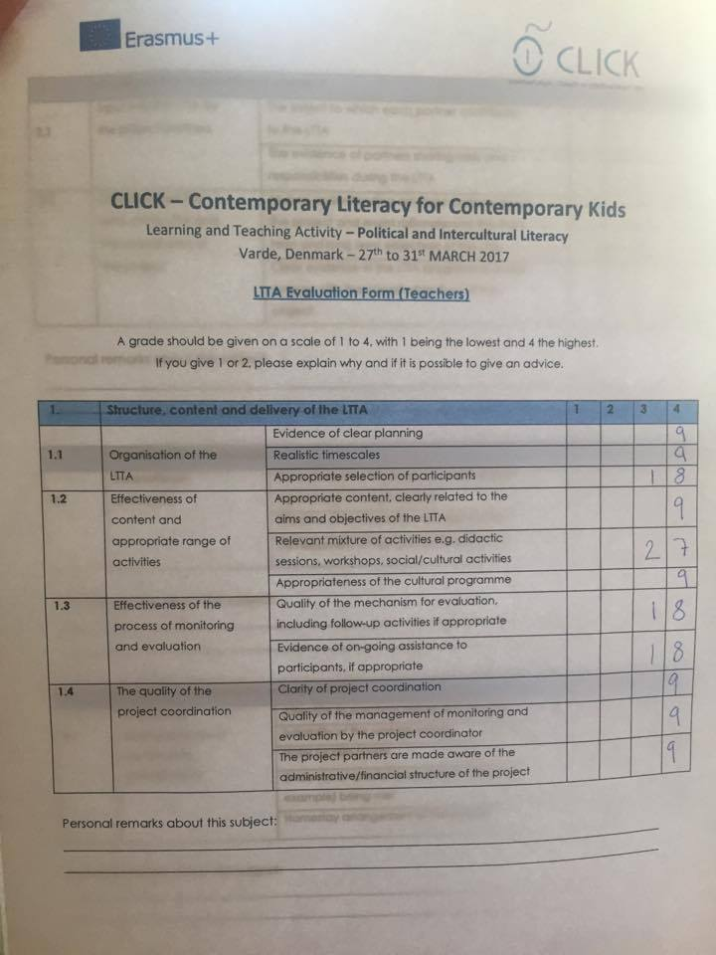

4. Next steps

We had two project management sessions, during which we covered the following agenda items:
- The second mid-term evaluation
- E-book
- Local dissemination activities so far
- The agenda of and practical information for the project meeting in Spain
- Materials we need to upload on our website
4.1. The second mid-term evaluation (updated version by 19. May)

We familiarised ourselves with the summary of our answers. We agreed that each partner can and actually should work on their answers in sections:
2.1 (Qualitative objectives = outcomes/new knowledge/skills) and
2.3 (Quantitative objectives = outputs/papers/posters/news/products /presentations/the number of activities and participants)
For that purpose, the summary document has been turned into a joint Google document, which each partner can edit.

4.2. The e-book and the practical classroom activities (deadline 28 May)

We evaluated the general design and structure of the book. We also discussed the way we are going to present our classroom activities in it. We agreed that the number of pages per activity can be more than 3 if needed. Still, we cannot change the structure provided by Marta, and we cannot change the fonts. Please use a separate Template B to fill in the required sections for three separate classroom activities. I will then myself place them in the book. See the attachment.

In order to have a full clarity what each of us will need to do, have a look at the table below:

Practical classroom activities
Digital/Technology | Information/Media | Political/Intercultural
Denmark Yes, but … | Denmark | Denmark
Estonia- Yes! | Estonia | Estonia
Portugal | Portugal | Portugal
Romania - Yes! (Name?) | Romania | Romania
Spain - Yes! (Title?) | Spain | Spain
Turkey | Turkey | Turkey

4.3. Local dissemination activities so far (deadline 5 June, just before our meeting)

Each partner is responsible for updating their ‘Local Activities’ pages on our website. Please do it with due diligence. Also, try to upload 6-8 pieces of evidence, which could be accessed via hyperlinks from your text.

4.4. The agenda for the project meeting in Spain

We agreed to cover the following agenda items:
- Project website and e-book (Triin and partners)
- Budget and Time Management (Triin); Quality Management (Albano); Risk Management (Eda)
- Dissemination (Lene); Implementation (Ana); Sustainability (Mihaela)
- Final Report: summarising the outcomes and outputs; final evaluation; main concepts (all partners)
As regards reporting on six areas of the project management, each responsible partner is free to ask the other partners provide some information and/or evidence to complete the report. Each partner then decides by which date they need that information.

4.5. Materials we need to upload on our website

YouTube videos:
- Portugal: available, needs uploading
- Turkey: Eda, could you please resend me the Youtube link with the cool video your students did when we were in Izmit. Thanks.
- Romania: Mihaela, as we agreed in Varde, the video on Romania needs some data to be added. Thanks.
- Denmark: Camilla, if you could come up with something similar (or different) you did in Romania, it would be great. ASAP
The scripts of the speaker’s corner speeches
- I’ve already got the scripts from Turkey.
- I’m looking forward to the rest of the scripts by week 17.
LTTA 3 (materials from the Danish team)
- The Activities Plan (in form of the joint table similar to those you find on our website under ‘Transnational Activities’ – “What did we do?”
- A presentation on Danish asylum policy, EU regulations on refugees and intercultural awareness by …
- The Headmaster’s speech
- A presentation on citizenship and democracy by …
- A presentation on Varde community (by this nice gentleman who talked to us instead of the Mayor) ASAP

Reflection papers (as blog posts, but also as entries to our handbook)
- Lene – Yes!
- Triin – Yes!
- Albano/Clara/Marta − to be submitted yet
- Mihaea/Raluca − to be submitted yet
- Ana/Olga − to be submitted yet
- Eda − to be submitted yet
Please take your time, but try to email me your compositions at last by 28 May, together with the classroom activities. Thanks.
List of references

Bennett, J.M., Bennett, M.J. 2004. Developing Intercultural Sensitivity: An Integrative Approach to Global and Domestic Diversity. In Landis, Bennett & Bennett (eds) Handbook of Intercultural Training: Sage Publications.
Bennett, M.J. 2011. What All Interculturalists Need to Know: Why They are Not Cross-Cultural Psychologists, Anthropologists, or Internationalists. SIETAR Italia. Annual meeting. Available at http://www.youtube.com/watch?v=CD-wtfrB4ZQ, accessed May 10, 2017
European Commission. 2007. European Cultural Values. Eurobarometer 278. Available at http://ec.europa.eu/culture/pdf/doc958_en.pdf, accessed May 10, 2017
Europublic. 2007. Study of the intercultural skills taught in foreign languages courses at each stage of compulsory education and training in the European Union. Final Report. Available at http://ec.europa.eu/education/languages/archive/doc/lace_en.pdf, accessed May 10, 2017
Hofstede, G. 2001. Cultures’ Consequences.t Second Edition, USA, Sage Publications Inc
Maitles, H. 1997. Teaching Political Literacy. Paper presented at the Scottish Educational Research Association Annual Conference (September 18- 20 1997: University of Dundee). Available at http://www.leeds.ac.uk/educol/documents/000000417.htm , accessed May 10, 2017

Annexe one: The Programme of LTTA 3 in Denmark

 | 27/03 | S | T | 28/03 | S | T | 29/03 | S | T | 30/03 | S | T | 31/03 | S | T
08:00−09.30 | Partners’ reception at Varde Campus  Official opening of the 3rd LTTA (1)  Practical information (2)  Visiting Varde Campus facilities | All |  | Warm up activities on critical thinking and problem solving related to intercultural awareness (case studies on crossing cultural differences) | All |  | Activities on citizenship and political debating (case studies on democracy) (11) | All |  | A TRIP TO RIBE (15)  (Denmark’s oldest town) | All |  | Presentations like a rally/joint meeting (16) | All
 | Coffee break |  |  | Coffee break |  |  | Coffee break |  |  |  |  |  | Coffee break
9:55-11:20 | Hopes and Fears session (3)  Presentations  “My Country in a Bag” (4) | All |  | Activities on critical thinking and problem solving related to intercultural awareness (case studies on crossing cultural differences) (7)  Students’ roundtable discussion | All |  | Field trip to  Varde town hall and meeting the mayor Erik Buhl (12)  Introducing the municipality of Varde | All |  |  |  |  | Results from the tests (17)  LTTA evaluation  Certifications for both students and teachers | All
 | LUNCH |  |  | LUNCH |  |  | LUNCH (late) |  |  |  |  |  | LUNCH

11.55-13.25 | WORK SHOP  Team building in the surroundings of Varde Campus (5) |  | Students playing games of dilemmas and meeting local refugees (8)  Teachers planning ahead for the 3rd  transnational project meeting in Spain | S | T | Field trip to  continued (12) | All |  |  | All |  | Exhibition "ENERGY FROM THE SEA” - Danish Offshore in the North Sea (18) | All
 | Coffee break | All | Coffee break |  |  | Coffee break
13.35-15.05 | When the students return home, the teachers have a meeting. (6) |  | WORK SHOP:  Speakers’ corner – like in Hyde Park in London. (9) |  |  | Teachers’ roundtable (13)  WORK SHOP:  The ideal country of C.L.I.C.K. (14) | S | T
 | FREE TIME
19:00 | Dinner |  | Festive Dinner (10) |  | Dinner |  |  | Dinner |  |  | Dinner

ANNEXE 2: Hopes and Fears

Before every LTTA the teachers and students who are travelling abroad must fill out a document, where they’ll have to write their hopes and fears about the next LTTA and email them to the host country/school. The hopes and fears can be about everything, such as weather, food, flying, communication, or activities – anything that may concern the students and teachers. | 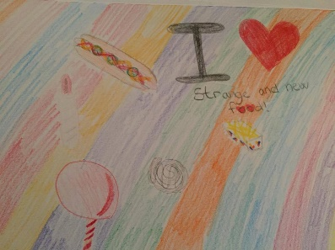
When the host country receives the documents, they’ll have to make “a presentation” out of these hopes and fears, so that every student and teacher who participates in the LTTA have seen and considered the different hopes and fears their partners might have had before travelling. | 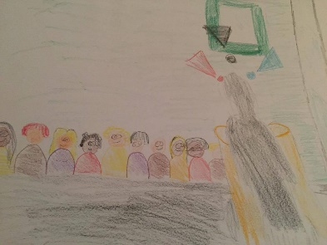
We really wanted the Danish students to take part in the interpretation and presentation; therefore, we told them to draw the different hopes and fears on a piece of paper. Every student had a different hope or fear they had to draw. Afterwards they had to write their own hopes and fears, and some of them were asked to make a short video, where they had to tell one of the things they had written in their own document. | 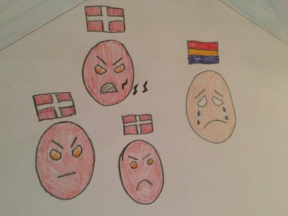
In the end, we collected all the drawings, the videos from the Danish students and wrote down some of the hopes and fears from the other countries, added music and made our own made our own hopes-and-fears-music-video available at https://www.youtube.com/watch?v=zXNfalcmH1o&feature=youtu.be | 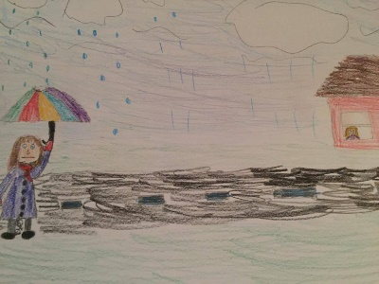

ANNEXE 3: The List of Participants

 | Country | Students | Teachers
Denmark |  | - Cosmin Florea  - Mikkel Roldsgaard  - Miklas Trolle  - Trine Falk Beyer  - Sarah Holm  - Rico Kristensen  - Pernille Nielsen  - Ophelia Pedersen  - Nicklas Brodersen  - Nanna-Michelle Nielsen  - Matilde Sigersted  - Laura Roldsgaard  - Ida Sommer  - Emma Bak  - Emma Wiltman  - Denisa Radoncic  - Benja Madsen | - Camilla Holjund  - Lene Dall Berthelsen
Estonia |  | - Kristi Kütt  - Angela Allik | - Liia Vijand  - Triin Lingiene
Portugal |  | - Ana Daniela Leal  - Fabio Queiroz | - Albano Vascancelos  - Clara Ferraz
Spain |  | - Hannah Pedlar Panos  - Marina Asensi Esparcia | - Olga Ortiz Polo  - Ana Belen Minguez Zanon
Romania |  | - Valentina E. Vasilache  - Daniel Behenaru | - Mihaela Jarcau  - Raluca Horvat
Turkey |  | - Umut Serkan  - Eslem Seymen  - Ecegül Konca  - Sevval Senkul  - Simge Yildiz  - Yusuf Gencer | - Eda Tosun  - Tolga Burak Kili

ANNEXE 4: Checklists

Sessions

1 | Pre-test (How many?) | yes
2 | School presentations “My country in a bag” (31 students and 12 teachers) | yes
3 | Hopes and fears (31 students and 12 teachers) | yes
4 | Activity 1 (31 students and 12 teachers) | yes
5 | Activity 2 (31 students and 12 teachers) | yes
6 | Activity 3 (31 students and 12 teachers) | yes
7 | Activity 4 (31 students and 12 teachers) | yes
8 | Feedback session (31 students and 12 teachers) | yes
9 | Post-test (How many?) | Yes/no?

Cultural activities

1 | Field trip in Varde (31 students and 12 teachers) | yes
2 | Field trip to Ribbe (31 students and 12 teachers) | yes
3 | Field trip to Esbjerg (31 students and 12 teachers) | yes

Round-tables

Teachers (the core team) Students (31)

1 | Project Management | yes |  | 1 | Workshops | yes
2 | Second mid-term evaluation | yes |  | 2 | Student round-tables | yes
3 | The e-book | yes
4 | Nest steps (The last project meeting in Valencia) | yes

